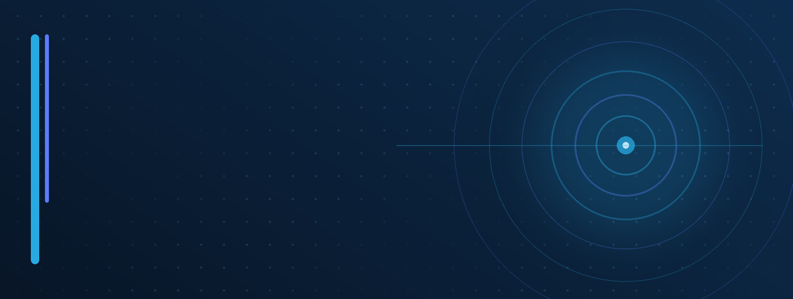
PROPOSAL v1.0 | AUGUST 14, 2026
CUSTOM GIT-BACKED
CMS PROPOSAL
Ophthalytics Content Editor and Controlled Publishing Workflow
GOVERNANCE PRINCIPLE
There is one true production administrator: the Repository Owner. Everyone else signs in as a CMS Editor and can only prepare changes that the CMS submits as pull requests for review.

Prepared for
Ophthalytics, Inc.
Prepared by
Alexander Blair
Repository Owner and Web Administrator

01 PROPOSAL SECTION
Executive Summary
A custom CMS can be added without replacing the Astro site, surrendering design control, or weakening the protected main branch.

RECOMMENDATION
Build an internal, Git-backed, block-based editor at admin.ophthalytics.com. Editors receive a friendly visual interface. Their submissions become branches and pull requests. Only the Repository Owner can approve, merge, and cause a production deployment.

01  KEEP THE CURRENT SITE  Retain the custom Astro frontend, components, styling, motion, SEO structure, and Vercel production project. | 02  ADD A FRIENDLY EDITOR  Authorized staff edit approved text, images, articles, cards, and section order without touching source code. | 03  PRESERVE THE GATE  The CMS can open PRs, but it cannot push to main, merge, change branch rules, or deploy production.

What this solves
• Routine content updates no longer require a developer to manually edit every sentence or card.
• The founder and approved staff receive a WordPress-like editing experience without adopting WordPress.
• Every proposed change remains reviewable, attributable, reversible, and protected by the existing GitHub workflow.
• The public website remains fast and static; the admin application can fail independently without taking the marketing site down.
What this does not do
• It does not grant CMS users repository administration, direct production access, or the ability to bypass the Repository Owner.
• It does not attempt to recreate a free-form Elementor/Webflow page builder in the first release.
• It does not require a conventional database for published content or an external CMS vendor.

02 PROPOSAL SECTION
Current State and Proposed Scope
The repository already contains the visual system and reusable components needed for a controlled editor. The primary refactor is separating editable content from presentation code.

REPOSITORY FIT  • Astro 6.1.7 static marketing site with Tailwind 4.2.2.  • Reusable components already exist for hero, resource, team, product, audience, testimonial, and CTA patterns.  • Vercel is already connected to GitHub and main functions as the production branch.  • The existing design can remain code-controlled while approved content becomes data-driven. | CURRENT LIMITATION  • Homepage copy and section data are embedded in src/pages/index.astro.  • Team and advisor content is embedded in src/pages/about.astro.  • Newsroom entries are maintained in a hardcoded array.  • Header, announcement, navigation, and footer content are embedded in layout components.

Recommended editable surface
GLOBAL CONTENT  Announcement bar, navigation labels, footer CTA, contact information, selected SEO fields. | STRUCTURED CONTENT  Newsroom posts, journal entries, articles, team members, advisors, events, partners. | PAGE CONTENT  Hero copy, approved images, solution copy, cards, testimonials, and approved section ordering.

BOUNDARY
Editors can change the data supplied to approved components. They cannot edit Astro templates, Tailwind classes, JavaScript, global design tokens, repository settings, or deployment configuration.

Not included in the first release
Arbitrary pixel positioning, custom HTML blocks, custom CSS, custom JavaScript, unrestricted layout construction, plugin installation, and direct production publishing are intentionally excluded.

03 PROPOSAL SECTION
Governance and Permission Model
The CMS must express the existing authority model accurately: one Repository Owner / Production Administrator, with all other authenticated users treated as CMS Editors.

NON-NEGOTIABLE CONTROL
No CMS Editor receives a direct path to main. No editor token or application credential may have ruleset bypass, administration permission, merge permission, or production deployment authority.

REPOSITORY OWNER / PRODUCTION ADMIN  Owns the repository. Controls branch rules, GitHub App installation, editor allowlist, schemas, code, merge decisions, rollbacks, Vercel production settings, and final publication. | CMS EDITOR  Signs into the editor, changes approved fields, reorders approved blocks, uploads validated assets, previews work, saves drafts, and submits a pull request through the CMS layer.

Permission matrix
CAPABILITY | SOLE ADMIN | CMS EDITOR
Sign in to admin.ophthalytics.com | YES | YES
Edit approved text, images, cards, and articles | YES | YES
Reorder approved sections and cards | YES | YES
Save a draft and submit a PR | YES | YES
View the Vercel preview and PR status | YES | YES
Change schemas, components, code, or styling | YES | NO
Manage editor access and GitHub App permissions | YES | NO
Push directly to main | OWNER ONLY | NO
Approve or merge a pull request | OWNER ONLY | NO
Modify branch protections or bypass rules | OWNER ONLY | NO
Trigger a production deployment by merging main | OWNER ONLY | NO

Editor attribution: CMS-generated PRs are opened by the GitHub App, while the authenticated editor's name/email and change summary are recorded in the PR body and audit log. Editors do not need personal access tokens or repository administrator accounts.

04 PROPOSAL SECTION
Editor Experience
The UI should feel simple and visual, but its freedom must be constrained to safe, reusable components.

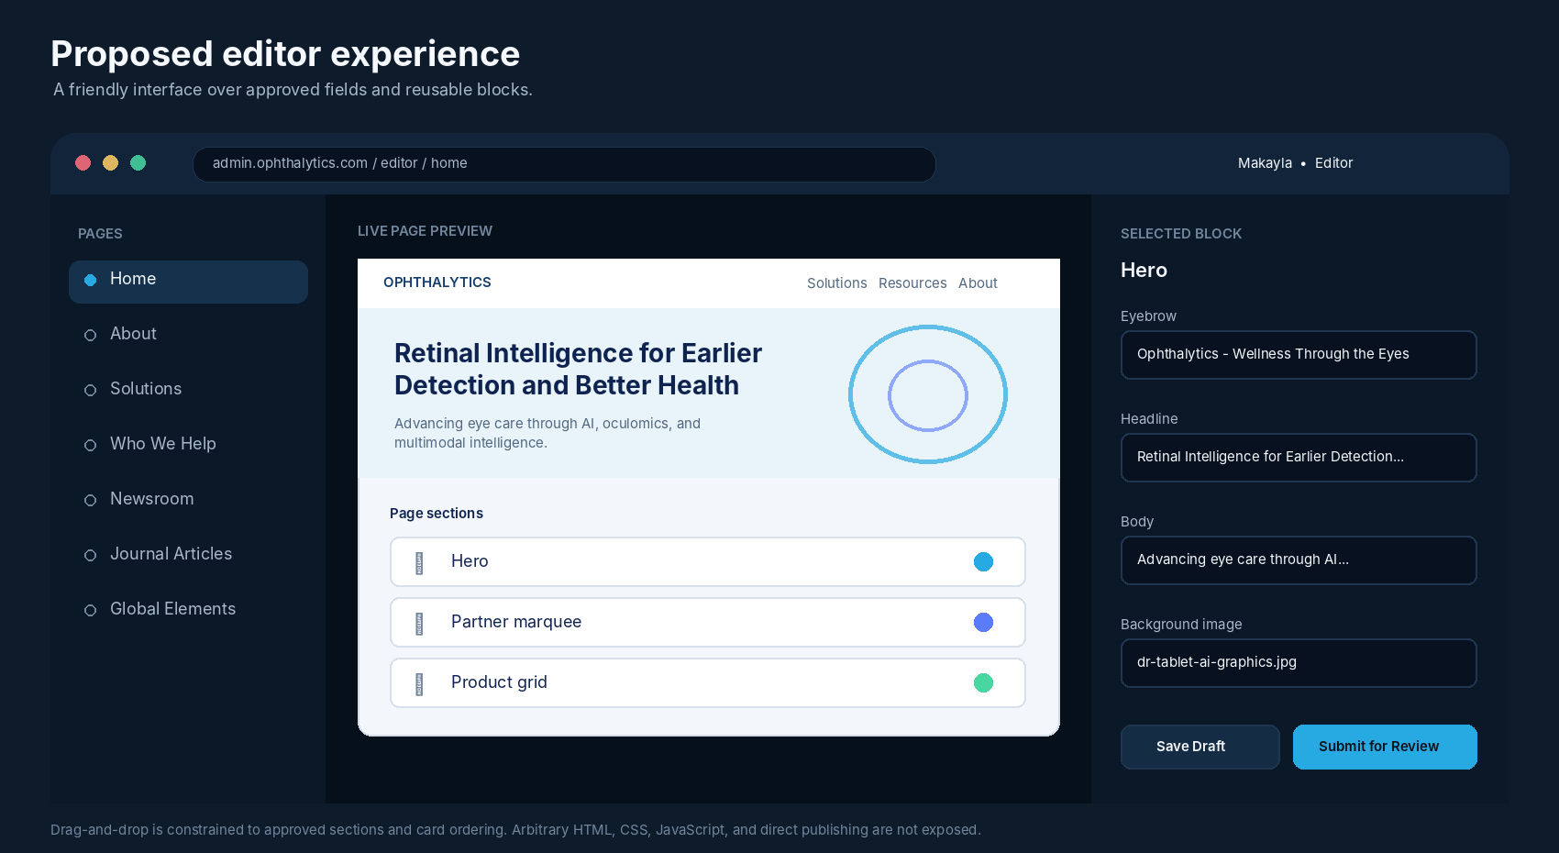
1  SIGN IN  Use company Google, Microsoft, or GitHub OAuth/OIDC. The server checks an approved editor allowlist. | 2  EDIT  Select a page, change fields, upload safe media, and reorder approved sections or cards. | 3  PREVIEW  See a faithful page preview before submitting. Validation blocks incomplete or unsafe content. | 4  SUBMIT  Click Submit for Review. The CMS creates a branch, commit, pull request, and Vercel preview.

BUTTON LANGUAGE
Editors should see “Save Draft” and “Submit for Review,” not “Publish.” Production publication occurs only after the Repository Owner reviews and merges the PR.

The drag-and-drop feature should reorder known sections and cards. It should not expose arbitrary coordinates, raw HTML, layout CSS, scripts, or responsive breakpoints. This keeps the site visually consistent and dramatically reduces implementation risk.

05 PROPOSAL SECTION
Technical Architecture
Use separate public and admin applications connected to the same repository. The public site stays static; the admin app receives server-side authentication and GitHub integration.

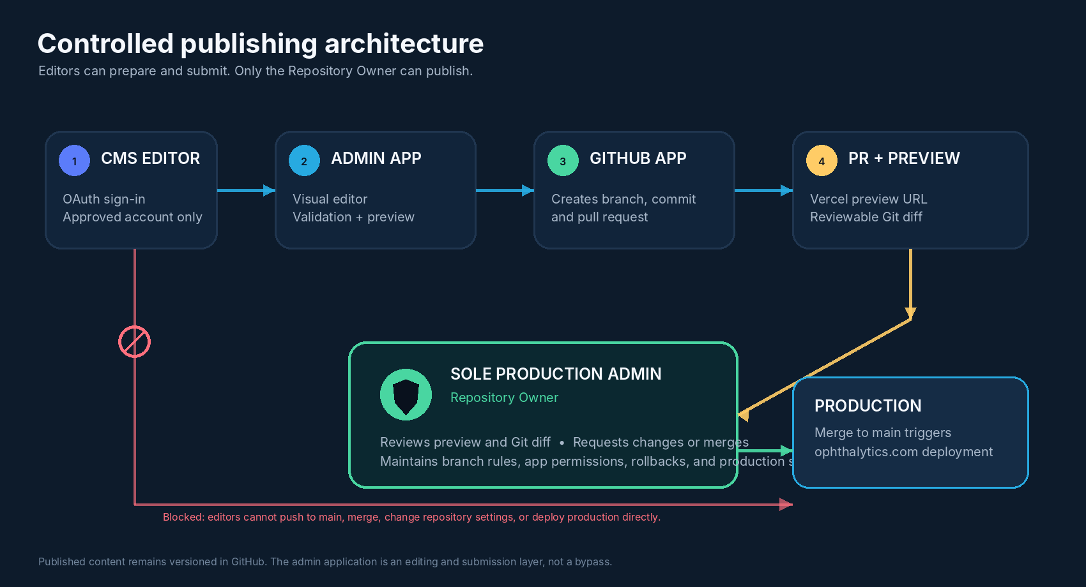
PUBLIC SITE  Existing Astro application at ophthalytics.com. Reads approved JSON/Markdown during the build and serves static output. | ADMIN APP  Separate application at admin.ophthalytics.com. Provides OAuth login, editor UI, validation, preview, and submission APIs. | GITHUB APP  Installed only on alenzie/Marketing-Site with narrowly scoped Contents and Pull Requests permissions. No administration or bypass.

Recommended repository layout
Marketing-Site/
├── src/ # existing public Astro site
├── src/content/ # approved JSON/Markdown content
├── public/uploads/ # validated CMS media (MVP)
├── admin/ # authenticated editor application
└── packages/content-schema/ # shared validation and block types

Vercel can connect multiple projects to one repository using different root directories. The public project keeps the production domain; the admin project receives the admin subdomain and server-only environment variables.

06 PROPOSAL SECTION
Content Store, Database, and Publishing Flow
Published website content can remain entirely Git-backed. A conventional CMS database is optional, not required.

WHERE DATA LIVES  • Published content: JSON and Markdown files in GitHub.  • Media (MVP): optimized files committed under public/uploads.  • Version history: Git commits and pull requests.  • Approval queue: open pull requests against main.  • Production state: the content currently merged into main. | DATABASE POSITION  • No database is required for published content.  • OAuth identity plus signed HTTP-only sessions can avoid a password database.  • The editor allowlist can begin as a server-only configuration managed by the Repository Owner.  • A small database can be added later for autosave, multi-device drafts, audit search, or collaborative editing.

Example content records
src/content/globals/footer.json
src/content/pages/home.json
src/content/team/awais-bajwa.json
src/content/newsroom/retina-2026.md
public/uploads/2026/08/retina-summit.webp

Submission lifecycle
1. The editor signs in and modifies an approved content model.
2. The server validates schema, links, media type, file size, and allowed block combinations.
3. The GitHub App creates a branch such as cms/makayla/home-hero-20260814.
4. The app commits only the changed content/media files and opens a pull request against main.
5. Vercel creates a preview deployment for review.
6. The Repository Owner requests changes or merges. A merge to main triggers production deployment.
The CMS layer does not directly “push a deployment.” It proposes a Git change. GitHub protection and the Repository Owner remain the publication authority; Vercel performs deployment after the approved merge.

07 PROPOSAL SECTION
Implementation Plan and Effort
Start with one complete vertical slice, prove the PR and preview workflow, then expand the editable surface in controlled phases.

# | PHASE | DELIVERABLE | EFFORT
0 | Content inventory and schema decisions | List editable fields, locked components, editor accounts, media rules, and acceptance tests. | 2-3 days
1 | Content extraction and Astro refactor | Move hardcoded content into validated JSON/Markdown; preserve current visuals and URLs. | 5-8 days
2 | Admin shell and OAuth access | Create admin.ophthalytics.com, approved-account login, sessions, page list, and field forms. | 4-6 days
3 | GitHub App and PR pipeline | Create branches, commits, PR bodies, labels, editor attribution, conflict handling, and status views. | 4-6 days
4 | Preview and block editor | Add live preview, safe media upload, drag-to-reorder approved blocks/cards, and validation feedback. | 7-12 days
5 | Hardening and pilot | Security review, rate limits, sanitization, error recovery, documentation, and editor pilot. | 5-8 days

PROOF OF CONCEPT  2-4 days: log in, edit the circled footer CTA, submit a PR, view preview, merge, and verify production. | USEFUL MVP  Approximately 4-6 focused weeks: global content, homepage essentials, Newsroom, team entries, images, preview, and PR flow. | POLISHED V1  Approximately 7-10 focused weeks: broader page coverage, refined block editing, audit tooling, conflicts, autosave, and stronger operations.

SEQUENCING RECOMMENDATION
Build the footer CTA vertical slice first. It exercises authentication, content extraction, GitHub App permissions, PR creation, Vercel preview, owner approval, and production deployment with minimal page risk.

Time estimates assume reuse of established libraries for OAuth, rich text, sorting, validation, and GitHub integration. Reimplementing those foundations from scratch would materially increase risk and schedule.

08 PROPOSAL SECTION
Security, Operational Controls, and Risks
The editor is a privileged internal system. Its permissions should be minimal, auditable, and structurally incapable of bypassing the protected publication path.

Required controls
IDENTITY  OAuth/OIDC login, approved account allowlist, secure HTTP-only sessions, CSRF protection, rate limits, and account removal controlled by the owner. | GITHUB  GitHub App installed only on Marketing-Site, short-lived installation tokens, narrowly scoped Contents and Pull Requests access, and no ruleset bypass. | CONTENT  Strict Zod/Astro schemas, sanitized rich text, URL validation, media type/size limits, generated filenames, and no arbitrary scripts or SVG uploads.

Key risks and mitigations
RISK | MITIGATION
Drag-and-drop scope creep | Restrict movement to an approved block registry and card ordering. Keep layout and breakpoints in code.
Merge conflicts from parallel edits | Create one PR per submission, show stale-base warnings, and require rebase/regeneration before merge.
Repository growth from media | Compress images automatically, enforce limits, detect duplicates, and move to object storage if volume grows.
Credential exposure | Keep OAuth secrets and GitHub App private key server-side only; never place them in client bundles or content files.
Editors expect instant publication | Use clear Draft / Submitted / Changes Requested / Merged states and label the action Submit for Review.
Healthcare compliance confusion | Limit the CMS to public marketing content. Do not store PHI, patient data, diagnostic records, or clinical workflow data.

COMPLIANCE NOTE
This proposal describes a marketing-content workflow, not a HIPAA or regulatory certification. The editor should be explicitly prohibited from accepting protected health information or patient-specific content.

09 PROPOSAL SECTION
Acceptance Criteria and Decision Requested
The project should be considered successful only when friendly editing and strict production control both work as designed.

Minimum acceptance criteria
1 | Approved editors can sign in without receiving a PAT, repository administrator role, or direct production credentials.
2 | Editors can change approved content, upload validated media, reorder approved blocks, and preview the result.
3 | Every submission creates a separate branch and pull request against main with editor attribution and a clear summary.
4 | The CMS cannot push to main, merge its PR, alter branch protections, change repository settings, or bypass the Repository Owner.
5 | Vercel generates a preview for the proposed change, while ophthalytics.com remains unchanged until the owner merges.
6 | The Repository Owner can request changes, close, merge, revert, and audit every submission.
7 | The current visual design, URLs, SEO metadata, responsive behavior, and core performance remain intact after content extraction.
8 | The admin app and all related secrets are isolated from the public client bundle.

Decision requested
1. Approve the custom Git-backed CMS direction and reject a WordPress replatform.
2. Confirm admin.ophthalytics.com as the editor URL and the Repository Owner as the sole production administrator.
3. Confirm that all other authenticated users are CMS Editors with submission-only authority.
4. Approve the proof-of-concept scope: footer CTA edit, OAuth login, GitHub App PR creation, preview, owner merge, and production verification.
5. After the proof of concept, approve the prioritized MVP content types and editor allowlist.
FINAL RECOMMENDATION
Proceed with a constrained block editor, not a free-form website builder. This directly answers the founder's request for easy maintenance while preserving the custom site, the repository history, the protected main branch, and the Repository Owner's final authority.

Technical reference basis
• Internal repository review: package.json, astro.config.mjs, src/pages, src/components/content, and layout components. Open reference
• Astro Content Collections: structured local JSON/Markdown, schemas, and build-time content. Open reference
• GitHub Apps: granular permissions and short-lived installation access tokens. Open reference
• Vercel Git workflow: preview deployments for branches/PRs and production deployments from the production branch. Open reference
• Vercel monorepos: multiple projects connected to one repository using separate root directories. Open reference
Proposal status: ready for technical review and scope approval.

